Policy Number: VI-j-85-96

Key Words: Slips, Trips, Falls, safety, ladder safety

Stakeholders:
Management, workers, housekeeping, Occupational Health, Wellness & Safety, Joint Health and Safety Committee

Policy Statement:
This Program establishes procedures to eliminate workplace hazards related to slips, trips and falls, increase awareness to prevent slip, trips and fall incidents and injuries and outline safe work practice. The Ontario Safety Association for Community and Healthcare (OSACH) states that slips and falls are among the leading causes of injury in the community and health care work environments and result in a substantial cost to the health care system.

This procedure applies to all employees at Mount Sinai Hospital locations. For the purpose of this policy, temporary employees who have been hired through an outside agency are expected to follow the provisions of this policy.
Standards and Regulations:
Ontario’s, Occupational Health and Safety Act, Health Care and Residential Facilities Regulation
Mount Sinai Hospital’s, “Personal Protective Equipment Policy (Footwear and Eyewear)”, January 2010
Mount Sinai Hospital’s, “FACT SHEET - PERSONAL PROTECTIVE EQUIPMENT POLICY INFORMATION”, September 2009

Roles and Responsibilities:

Management
- Be aware of potential slip, trip and fall hazards in your work area and inform workers;
- Conduct inspections of the work area on a regular basis (see Appendix A);
- Investigate all slip, trip and fall hazard reports;
- Investigate all incident reports involving falls;
- Implement required corrective actions where required to prevent slips, trips and falls in the work areas (e.g. communicated spills to Housekeeping to provide clean up, ensure availability of warning signs etc.);
- Provide orientation and training on the slip, trip and fall prevention practices, where required;

Workers
- Be aware of slip, trip and fall hazards;
- Report slip, trip and fall hazards to their supervisor;
- Report all incidents of falls to their supervisor even if no injury occurs;
- Use warning signs to alert others of spills if clean-up is delayed;
- Avoid work practices and personal behaviours that may cause slip, trip and falls;
- Wear appropriate footwear;
- Attend orientation and training on slip, trip and fall prevention practices, where required.
- Ensure that extension cords, conduits, cables and hoses do not cut across walking surfaces or working spaces.

Housekeeping
- Remove waste materials from work areas regularly;
- Store equipment and materials properly;
- Upon notification, clean up spills immediately or use warning signs when clean up may be delayed;
- Use appropriate visible warning signage when completing work practices that may create a slip or fall hazard (i.e. washing floors etc.).

Program Components/Procedure:

1. SURFACE CONDITIONS
- All surfaces must be kept free of obstructions, hazards, cracks, holes, bumps and the accumulation of refuse, snow and ice.
- Finishes and/or protective materials used on work surfaces must not make the surface slippery.
- Visible warning signs should be used to identify a work surface that is likely to cause a worker to slip, such as if there is a spill or a work surface is slippery when it is being cleaned or polished.

2. WORK PRACTICES AND PERSONAL BEHAVIOUR
- During wet processes or when wet conditions are present ensure that non-slip work surfaces are used, provisions are made for dry-standing places or non-slip mats, drainage is adequate for the area and workers are using water resistant, non-slip footwear.
- Ensure that items you are carrying or pushing do not prevent you from seeing any obstructions, spills, etc.
- Always use installed light sources that provide sufficient lighting for your task, or use a flashlight if you enter a dark room where there is no light.
- Wear properly fitted footwear that is appropriate for the task you are completing.
- Do not cut through areas that are not designated or intended as walkways.
- Be aware of the condition of the surfaces in the area you are working.
- Be aware of the slips/trips/falls hazards that may arise during your work.
- No horseplay in the workplace.

3. WORKING FROM HEIGHTS
- If a worker is exposed to the hazard of falling more than 3 meters the worker shall wear a fall arrest system, except where the work is performed from a ladder.
- Workers must not stand upon a chair, box or other loose object while working, with the exception of a step stool. Ladders, scaffolding or work platforms should be used appropriately.
- Do not use metal or wire-bound ladders or scaffolding where there is a hazard that they may come in contact with any live electrical circuit or equipment.
- Do not use a ladder or scaffolding if you are in poor health, tired, under the influence of drugs or alcohol, or physically incapacitated.
- Wear clean, sturdy shoes with slip-resistant soles when using a ladder or scaffolding.
- Ladders and scaffolding must be placed on a firm, slip resistant footing and secured from movement so that they cannot be accidentally dislodged from position before being used.
- Do not exceed the labeled load-rating for a step stool, ladder or scaffolding.
- Permanent platforms that are accessible by fixed stairs or fixed ladders must be used when frequent access is required to equipment that is above or below a work surface.

3.1 Ladders
- All ladders must be CSA approved
- Always maintain three-point contact, face the ladder and hold onto the rungs when climbing up or down
- Unless specifically labeled otherwise, ladders are designed to be used by only one person at a time.
- Before using a ladder, read and follow all the labeled warnings and instructions specific to that ladder.
- Ladders must be inspected before every use to identify signs or wear, and to ensure the ladder has strength, stiffness and stability to support any load applied.
- Ladders must have rungs evenly spaces and be equipped with slip resistant feet.
- Wooden ladders must not be painted or coated with an opaque material.
- If a ladder is found to be damaged or defective, it must be disposed of immediately. If immediate disposal is not possible, tag the ladder with a sign indicating that the ladder is unsafe for use and remove as soon as possible.
Classification of Ladders
- Type I – Industrial
- Heavy-duty use such as that which is experienced by utilities, industrial contractors and other heavy-duty applications. There are 3 sub-classifications to this group:
  - Type 1AA Special duty, professional use – load capacity is 350 lbs.
  - Type 1A Extra heavy duty, professional use – load capacity is 300 lbs.
  - Type 1 Heavy duty, industrial use – load capacity is 250 lbs.
- Type II – Commercial
- Medium duty use, such as activities required for painters, offices or other light industrial or commercial uses.
  - Load capacity is 225 lbs.
- Type III – Household
- Light duty or household users. These are for light household use and for safety reason should have extremely limited application. Theses ladders have limited ability to withstand heavy use along with their limited load capacity.
  - Load capacity of 200 lbs.

3.1.1 Portable Ladders
- The maximum length of a portable ladder is 9 meters for a single ladder; 13 metres for an extension ladder or sectional ladder.
- Portable ladders must be placed on firm footing and secured against slipping
- Portable ladders between 6 to 9 meters must be securely fastened or held in place by one or more workers while being used.
- A portable ladder that exceeds 9 meters must be securely fastened or stabilized to prevent it from tipping or falling.
- The base of a portable ladder must slope one metre out for every three to four metres up.
- If a portable ladder may be endangered by traffic, station a worker to direct traffic or place barriers/warning signs at its foot.

3.1.2 Step Ladders
- The maximum length of a step ladder is 6 meters
- Before climbing, make sure legs are fully open and spreaders are locked.
- Set all 4 feet on firm, level surface. Do not place step ladder on unstable, loose, or slippery surfaces.
- Keep body centered between side rails. Do not overreach. Get down and move ladder as needed.
- Do not stand on the top of a step ladder or use the pail shelf as a step.
- Do not “walk” or “shift” ladder while working on it.
- Never climb a step ladder while it is closed and leaning against a surface.

3.1.3 Fixed Ladders
- Fixed ladders must be vertical with rest platforms at no more than 9 metre intervals. Each rest platform must be offset.
- Fixed ladders must have side rails that extend 90 cm above the surface to which they are intended to provide access and rungs that are at least 15 centimetres from the wall and space at regular intervals.
- When fixed ladders exceed 5 metres in height they must be fitted with safety cages starting no more than 2.2 metres above the lower end of the ladder and extending 90 cm above the surface to which they are intended to provide access.

3.2 Scaffolding
- Scaffolds must have a safe, secure means of access such as portable ladder, ramp or stairway.
- Scaffolds must be equipped with a guardrail.
- Scaffold work platforms must be no less than 480 mm wide.
- The footing and supports or the scaffold must be capable of carrying, without dangerous settling, all loads that are likely to be imposed on them.
- The scaffold must be capable of supporting 2 times the load without exceeding the allowable unit stresses for the materials used, and 4 times the load without overturning.
- Levelling jacks should be used to secure the unit to floor and compensate for uneven surfaces.
- The wheels at the base of a scaffold must be locked and secured to prevent movement, where applicable.

3.3 Guardrails
- All Guardrails must meet the requirements of the Ontario Building Code (Parts 3 and 4).
- Guardrails are required:
  - Around the perimeter of uncovered floor opening, roof or other surface to which a worker has access.
  - Around a machine, electrical installation, place or thing that is likely to endanger the safety of any worker
  - At an open side of a raised floor, mezzanine, balcony, gallery, landing, platform, walkway, stile, ramp or other surface.
  - At an open side of a vat, bin or tank whose top is less than 107 centimeters above the surrounding floor, ground, platform or other surface

List of Appendices:

Appendix A: Slips, trips, falls prevention inspection checklist
Appendix B: “NO FLIPS DUE TO SLIPS & TRIPS: Fall Prevention Tips” factsheet
Appendix C: Ladder Checklist Guide

APPENDIX A: SLIPS, TRIPS, FALLS PREVENTION INSPECTION CHECKLIST
This checklist may serve as a guide and reminder of some of the key aspects of a Slips, Trips and Falls Prevention Program.
Work practices
- Do employees wear appropriate footwear?
- Are general practices such as “Clean as you go” and “Pick up/wipe up spills immediately” communicated to employees?
- Is equipment carried and moved in a manner that does not obstruct views?
- Are tasks performed at a safe speed?
- Do employees know how to address spills, trip and fall hazards in the area (e.g. to address spills- communicate to
the area staff, call housekeeping at x5008, place warning sign; to address trip hazards such as materials stored/placed on the floor in high traffic areas- inform area staff, move trip hazard to the appropriate area)
Floors and Other Areas
- Are floors clean and clear of slip hazards (water, grease, paper, etc.)?
- Are warning signs available and used to warn of wet floors whenever required?
- Are floor surfaces slip-resistant where needed (spills, moisture or grease are likely to accumulate)?
- Are floors in good condition i.e. free of cracks, there are no holes, worn planks or loose boards/tiles?
- Are carpeted areas free of trip hazards (buckled, frayed areas and uneven surfaces)?
- Are there protruding objects such as nails, sharp corners, open cabinet drawers, trailing electrical wires?
Workplace Design
- Are aisles unobstructed?
- Are convex mirrors installed at blind corners?
- Are aisles wide enough to accommodate employees and equipment comfortably?
- Is the workplace lighting adequate?
- Is furniture, equipment and materials arranged to eliminate slip/trip/fall hazard in high traffic areas?
Waste Disposal
- Are there an adequate number of containers?
- Are waste containers located where the waste is produced?
- Are waste containers emptied regularly?
Equipment
- Are all handrails secure and in good repair?
- Are extensions, power cords, cables, etc. secured?
- Are all stepstools, ladders and scaffolds used appropriately and in good repair?
Storage
- Are storage areas safe and accessible?
- Is material stacked securely, blocked or interlocked, if possible?
- Are materials stored in areas that do not obstruct stairs, fire escapes, exits or firefighting equipment?
- Are materials stored in areas that do not interfere with workers or the flow of materials?
- Are bins or racks provided where material cannot be piled?
- Are all storage areas clearly marked?
- Do workers understand material storage and handling procedures, e.g.: are flammables kept in clearly marked
and approved containers in designated storage areas?

APPENDIX B: “No FLIPS DUE TO SLIPS & TRIPS: Fall Prevention Tips” 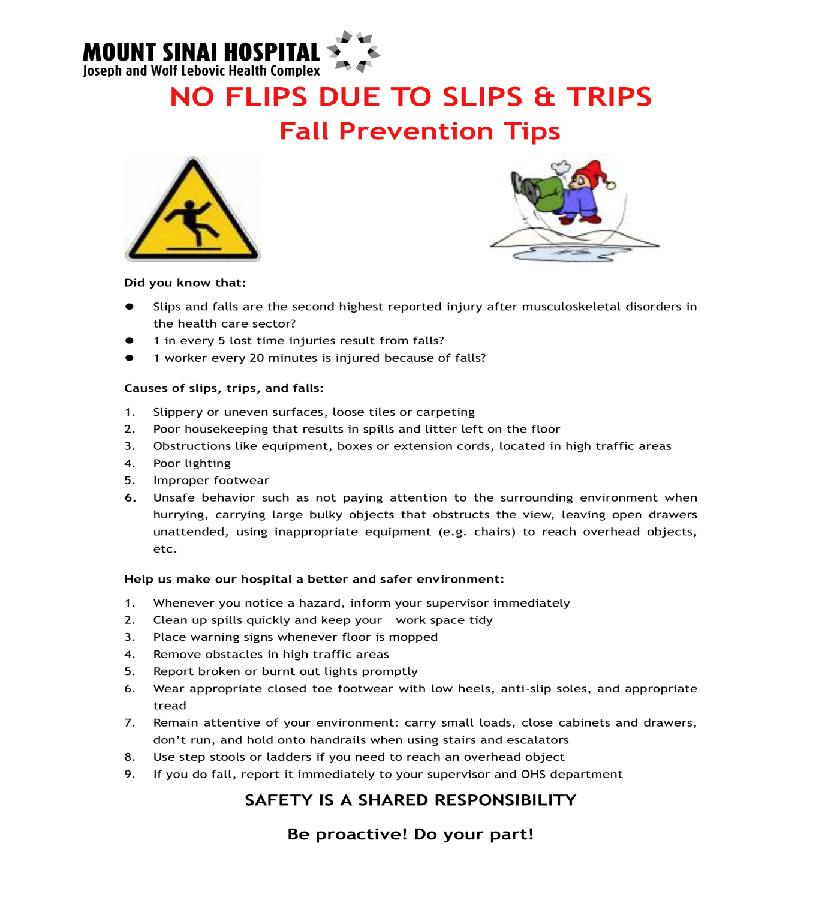
APPENDIX C: Ladder Checklist Guide
Tips for completing this checklist:
- This is a guide to assist you in checking and ensuring the ladders in your area are in good, safe working condition.
- Please ensure you complete this checklist on a monthly basis.
- Ensure you keep a copy of it in your records.
- Inspections don’t have to be completed by Management it can be assigned to a staff member who has been provided with training on what to look for.
Ensure that:

- All ladders have ID # on them.
- The inspection is part of your preventative maintenance program for ladders.
- Inspect all ladders which are assigned to you or you have purchased.
- Always check a ladder before using it. Inspect wood ladders for cracks and splits in the wood. Check all ladders to see that steps or rungs are tight and secure. Be sure that all hardware and fittings are properly and securely attached. Test movable parts to see that they operate without binding or without too much free play. Inspect metal and fiberglass ladders for bends and breaks.
- Inform all staff of what to do if a ladder is defective.

LADDER INSPECTION CHECKLIST
Ladder #: |  |  |  |  | Location:
Date Purchased: |  |  |  |  | Ladder length:
Ladder description:
Type of Ladder (circle): | Wood |  | Metal |  | Fiberglass |  |  |  | Aluminum |  |  |  | Other:
Ladder Style (circle): | Single |  | Extension |  | Platform |  |  |  | Stepladder |  |  |  | Other:
General Condition (circle): | Cracked |  | Bent/Dent |  | Sharp edges |  |  |  | Splits |  |  |  | Other:
Year: | Jan | Feb | Mar | Apr | May |  | Jun | Jul |  | Aug |  | Sep |  | Oct | Nov | Dec
PORTABLE LADDER | √ if in good condition X if in poor condition
Side Rails
Slide Guides
Safety Feet
Rungs
Gravity Locks
Safety Feet/Spurs
Fly Rope
Locking device
STEP LADDER | √ if in good condition X if in poor condition
Wobbly
Side Rails
Head Tray
Braces
Steps
Spreader Arms
Pail Shelf
Safety Feet
Inspection completed by: |  |  |  |  |  | Date of inspection:
Date removed from service: |  |  |  |  |  | Date returned to service:
Manager Signature: |  |  |  |  |  | Date:

